**Installation**

1.Clone repository from git.

2. Find database in the git repository (.zip file)

3. Restore to your local SQL instance.

4. Change connection string in appsetting.json to that of SQL instance.

**Usage**

The project/solution has the following functions as per assessment instructions.

Search for a vehicle

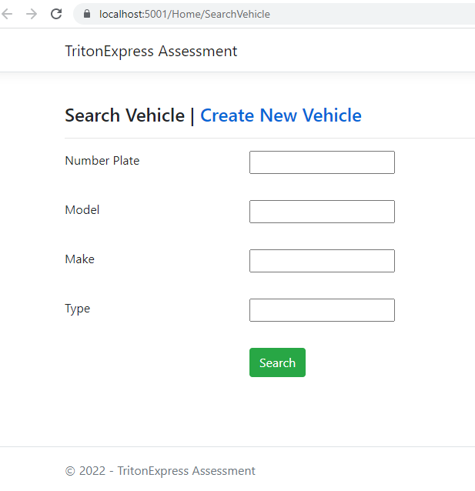

Vehicles List

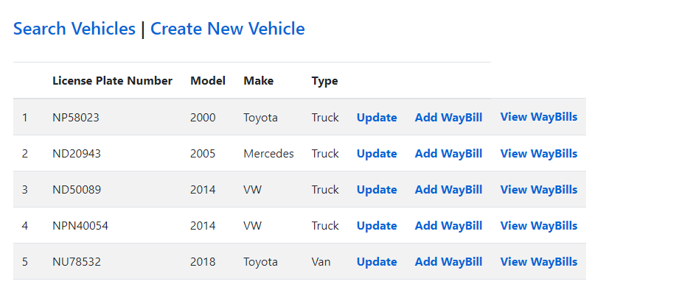

Create a vehicle

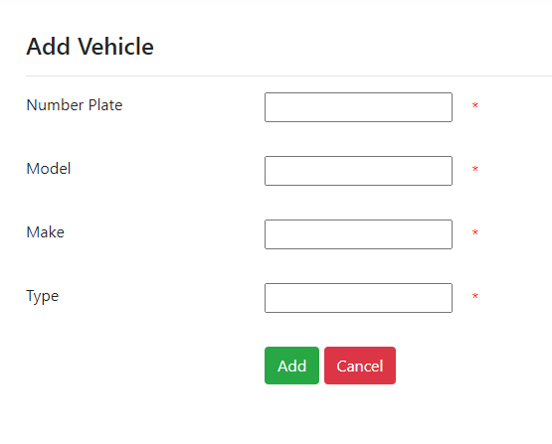

Update vehicle details

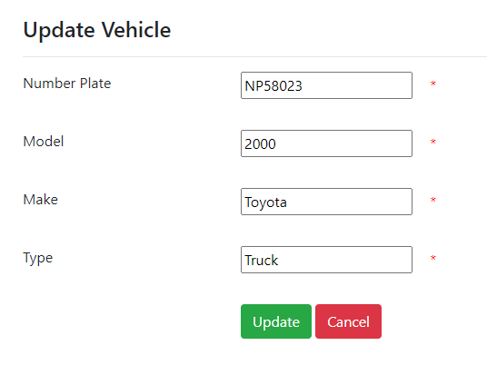

Assign waybills to vehicle

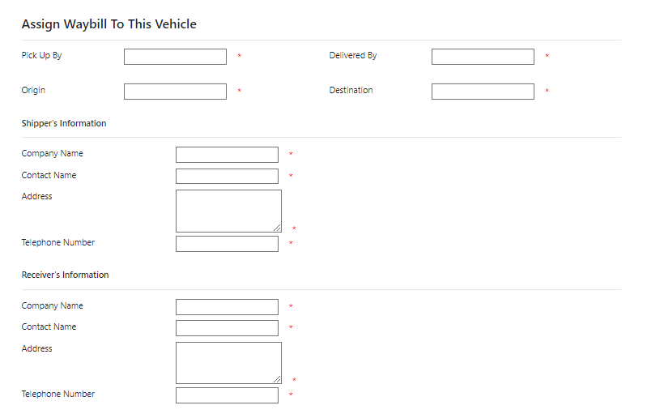

View Waybills assigned to a vehicle

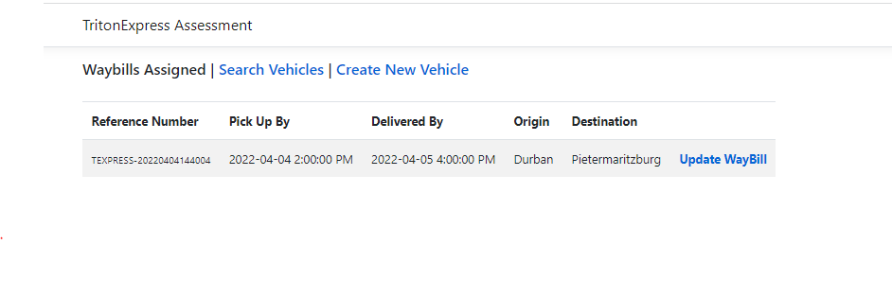

Update waybill details

